Giant Panda National Park Studio
LA 4008 & 7051 | Option Studio

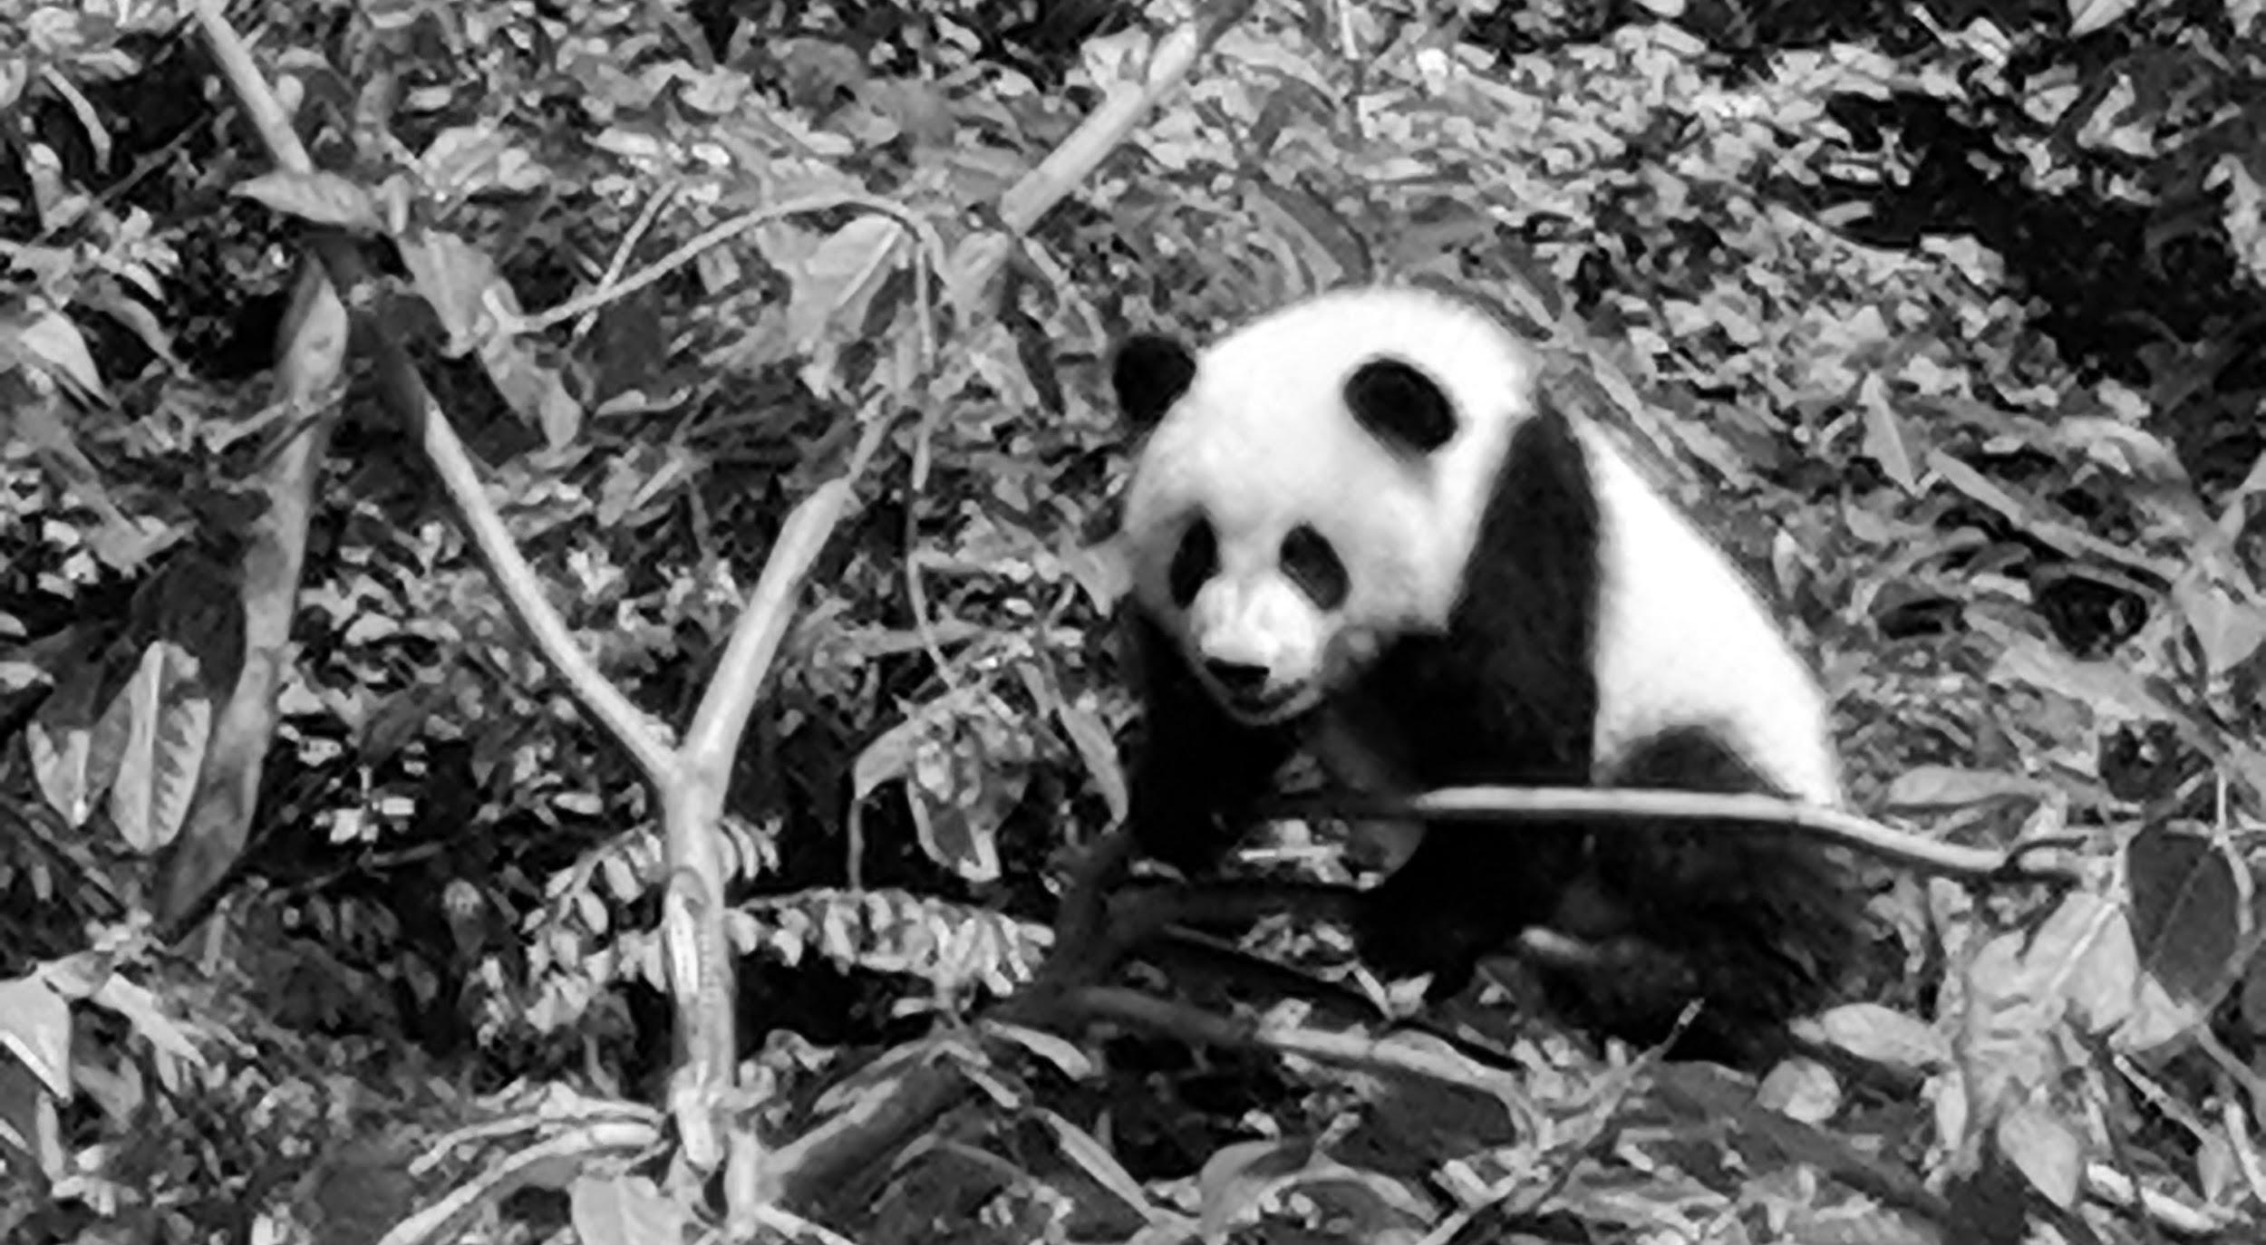

Instructor
Brendan Harmon, Louisiana State University, Robert Reich School of Landscape Architecture

Course Description In this studio you will work in partnership with Sichuan Agricultural University (SAU)’s College of Landscape Architecture to design a new national park for giant panda conservation and tourism in the wilds of Sichuan Province, China. Our study area, the Fengtongzhai National Nature Reserve, is a biodiversity hotspot for giant pandas, golden snub-nosed monkeys, and red pandas. After fieldwork in Fengtongzhai and geospatial data analysis, you will model and design the spatial configuration of the new national park and its connections to a greater ecological network. You will learn how to analyze remote sensing data and model habitat corridors, urban growth, and land change. After applying computational methods for ecology to landscape planning you will use generative design to develop a system of landscape and architectural elements and structures for the national park that respond to the unique geomorphology, ecology, and cultural heritage of the reserve. You will design a regional plan with habitat corridors, a masterplan for the park, structures, trails, signage, furniture, and an adaptive management plan. You will use generative systems to design structures including a visitor center, breeding center, lodges, and ranger stations and a family of landscape elements including bridges, signage, and furniture. You will publish your work in a report for the Chinese government. This course includes 2 weeks of optional fieldwork in Sichuan Province, China. You will take short courses and participate in a collaborative studio at SAU in Chengdu and travel to the Chengdu Panda Breeding Research Center, Fengtongzhai, Jiuzhaigou, Huanglong Valley, Mount Emei, Mount Qingcheng, and Dujiangyan. Theoretical topics will include critical regionalism, landscape ecology, island biogeography, conservation corridors, systematic conservation planning, biodiversity hotspots, adaptive management, and climate change.
Software | QGIS, GRASS GIS, Rhino, Grasshopper, & Adobe CC

This studio will be an introduction to computational methods for landscape ecology and planning. It will cover theory and computational methods for topics such as land change, systematic conservation planning, habitat fragmentation, and biodiversity conservation corridors. You will learn how to model ecological patterns and simulate ecological processes using Geographic Information Systems (GIS). Then you will use landscape planning methods in GIS and visual programming in Grasshopper to develop designs for a national park that respond to these ecological processes.

Weekly Course Schedule | August 17 – December 13, 2019
 | Landscape
1 | Fieldwork in Sichuan, China | 6 | Suitability analysis | 11 | Planning & design I
2 | Fieldwork in Sichuan, China | 7 | Land change modeling | 12 | Planning & design II
3 | Terrain modeling and fabrication | 8 | Ecological corridors and networks | 13 | Planning & design III
4 | Landscape ecology | 9 | Corridor design | 14 | Planning & design IV
5 | Landscape fragmentation | 10 | Generative systems | 15 | Final review

Fieldwork Itinerary | August 17-31, 2019
Day | Activity | Location | Day | Activity | Location
8/17 | Flight | Baton Rouge - Chengdu | 8/24 | Travel | Emeishan
8/18 | Chinese Lang. | Sichuan Agricultural Univ. | 8/25 | Travel | Emeishan
8/19 | Travel | Dujiangyan & Mt. Qingcheng | 8/26 | Ink Painting | Sichuan Agricultural Univ.
8/20 | Travel | Panda Breeding Center | 8/27 | Ink Painting | Sichuan Agricultural Univ.
8/21 | Gardens | Sichuan Agricultural Univ. | 8/28 | Tea Culture | Sichuan Agricultural Univ.
8/22 | Site Visit | Fengtongzhai | 8/29 | Tea Culture | Sichuan Agricultural Univ.
8/23 | Site Visit | Fengtongzhai | 8/30 | Bamboo | Sichuan Agricultural Univ.
 |  |  | 8/31 | Flight | Chengdu - Baton Rouge

The fieldwork excursion is optional, but highly recommended. Our partner and host, Sichuan Agricultural University, has generously agreed to fund most expenses in China except for tourist site tickets. Students will be responsible for airfare, visas, tourist tickets, and course fees. Course fees include travel insurance and tourist site tickets. I recommend each student bring around ¥1000 RMB (approx. $145 USD) in cash for personal expenses.

Student Budget
Category | Cost
Airfare | $1,250.00
Visa | $200.00
Course fee | $230.00
 | $1,680.00

